Engineering Statistics Handbook
6.1.6. | What is Process Capability?

Process capability compares the output of an in-control process to the specification limits by using capability indices. The comparison is made by forming the ratio of the spread between the process specifications (the specification "width") to the spread of the process values, as measured by 6 process standard deviation units (the process "width").
Process Capability Indices
A process capability index uses both the process variability and the process specifications to determine whether the process is "capable" | We are often required to compare the output of a stable process with the process specifications and make a statement about how well the process meets specification. To do this we compare the natural variability of a stable process with the process specification limits.  A capable process is one where almost all the measurements fall inside the specification limits. This can be represented pictorially by the plot below:  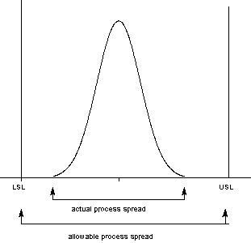  There are several statistics that can be used to measure the capability of a process: C_{p}, C_{pk}, C_{pm}.  Most capability indices estimates are valid only if the sample size used is 'large enough'. Large enough is generally thought to be about 50 independent data values.  The C_{p}, C_{pk}, and C_{pm} statistics assume that the population of data values is normally distributed. Assuming a two-sided specification, if and are the mean and standard deviation, respectively, of the normal data and USL, LSL, and T are the upper and lower specification limits and the target value, respectively, then the population capability indices are defined as follows:
Definitions of various process capability indices | 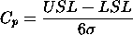  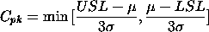  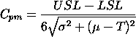
Sample estimates of capability indices | Sample estimators for these indices are given below. (Estimators are indicated with a "hat" over them).  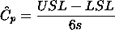  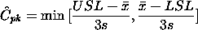  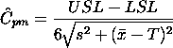  The estimator for C_{pk} can also be expressed as C_{pk} = C_{p}(1-k), where k is a scaled distance between the midpoint of the specification range, m, and the process mean, .  Denote the midpoint of the specification range by m = (USL+LSL)/2. The distance between the process mean, , and the optimum, which is m, is - m, where . The scaled distance is  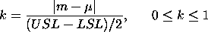  (the absolute sign takes care of the case when ). To determine the estimated value, , we estimate by . Note that .  The estimator for the C_{p} index, adjusted by the k factor, is  Since , it follows that .
Plot showing C_{p} for varying process widths | To get an idea of the value of the C_{p} statistic for varying process widths, consider the following plot  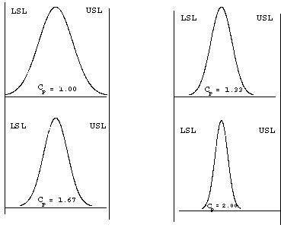  This can be expressed numerically by the table below:
Translating capability into "rejects" | where ppm = parts per million and ppb = parts per billion. Note that the reject figures are based on the assumption that the distribution is centered at .  We have discussed the situation with two spec. limits, the USL and LSL. This is known as the bilateral or two-sided case. There are many cases where only the lower or upper specifications are used. Using one spec limit is called unilateral or one-sided. The corresponding capability indices are
  USL - LSL | 6 | 8 | 10 | 12
  C_{p} | 1.00 | 1.33 | 1.66 | 2.00
  Rejects | .27% | 64 ppm | .6 ppm | 2 ppb
  % of spec used | 100 | 75 | 60 | 50
One-sided specifications and the corresponding capability indices | 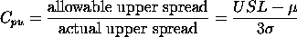  and  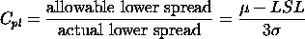  where and are the process mean and standard deviation, respectively.  Estimators of C_{pu} and C_{pl} are obtained by replacing and by and s, respectively. The following relationship holds  C_{p} = (C_{pu} + C_{pl}) /2.  This can be represented pictorially by  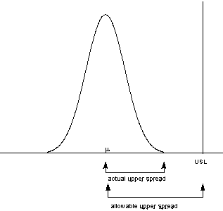  Note that we also can write:  C_{pk} = min {C_{pl}, C_{pu}}.
 | Confidence Limits For Capability Indices
Confidence intervals for indices | Assuming normally distributed process data, the distribution of the sample follows from a Chi-square distribution and and have distributions related to the non-central t distribution. Fortunately, approximate confidence limits related to the normal distribution have been derived. Various approximations to the distribution of have been proposed, including those given by Bissell (1990), and we will use a normal approximation.  The resulting formulas for confidence limits are given below:  100(1-)% Confidence Limits for C_{p}  where  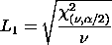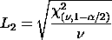  = degrees of freedom
Confidence Intervals for C_{pu} and C_{pl} | Approximate 100(1-)% confidence limits for C_{pu} with sample size n are:  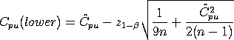  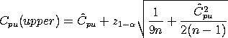  with z denoting the percent point function of the standard normal distribution. If is not known, set it to .  Limits for C_{pl} are obtained by replacing by .
Confidence Interval for C_{pk} | Zhang et al. (1990) derived the exact variance for the estimator of C_{pk} as well as an approximation for large n. The reference paper is Zhang, Stenback and Wardrop (1990), "Interval Estimation of the process capability index", Communications in Statistics: Theory and Methods, 19(21), 4455-4470.  The variance is obtained as follows:  Let  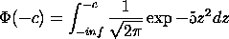  Then  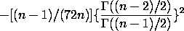  Their approximation is given by:  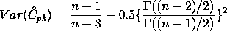  where  The following approximation is commonly used in practice  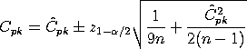  It is important to note that the sample size should be at least 25 before these approximations are valid. In general, however, we need n 100 for capability studies. Another point to observe is that variations are not negligible due to the randomness of capability indices.
 | Capability Index Example
An example | For a certain process the USL = 20 and the LSL = 8. The observed process average, = 16, and the standard deviation, s = 2. From this we obtain  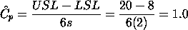  This means that the process is capable as long as it is located at the midpoint, m = (USL + LSL)/2 = 14.  But it doesn't, since = 16. The factor is found by  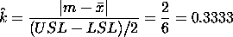  and  We would like to have at least 1.0, so this is not a good process. If possible, reduce the variability or/and center the process. We can compute the and  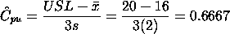  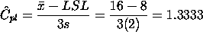  From this we see that the , which is the smallest of the above indices, is 0.6667. Note that the formula is the algebraic equivalent of the min{, } definition.
 | What happens if the process is not approximately normally distributed?
What you can do with non-normal data | The indices that we considered thus far are based on normality of the process distribution. This poses a problem when the process distribution is not normal. Without going into the specifics, we can list some remedies.  - Transform the data so that they become approximately normal. A popular transformation is the Box-Cox transformation  - Use or develop another set of indices, that apply to nonnormal distributions. One statistic is called C_{npk} (for non-parametric C_{pk}). Its estimator is calculated by  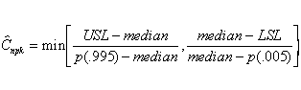  where p(0.995) is the 99.5th percentile of the data and p(.005) is the 0.5th percentile of the data.  For additional information on nonnormal distributions, see Johnson and Kotz (1993).  There is, of course, much more that can be said about the case of nonnormal data. However, if a Box-Cox transformation can be successfully performed, one is encouraged to use it.

